Views in Power BI

1. **Report View on Installation of Power BI**

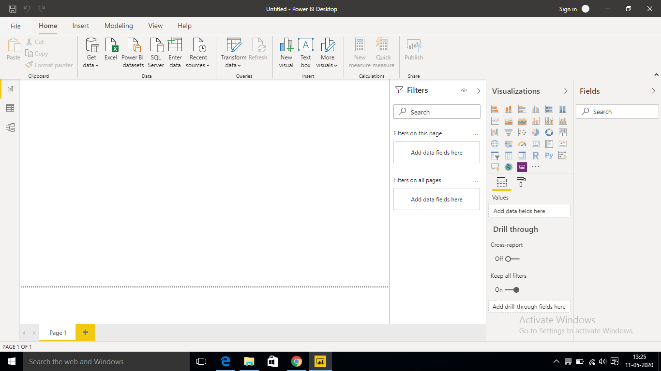

1. **a) Report View**

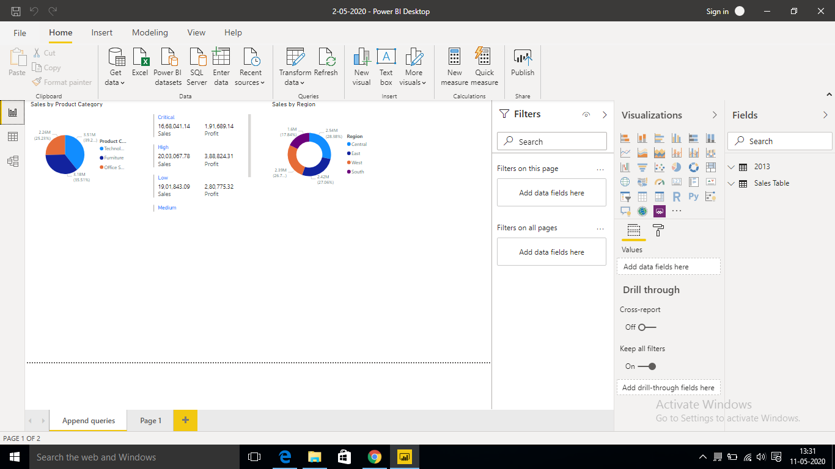

**b) Data View**

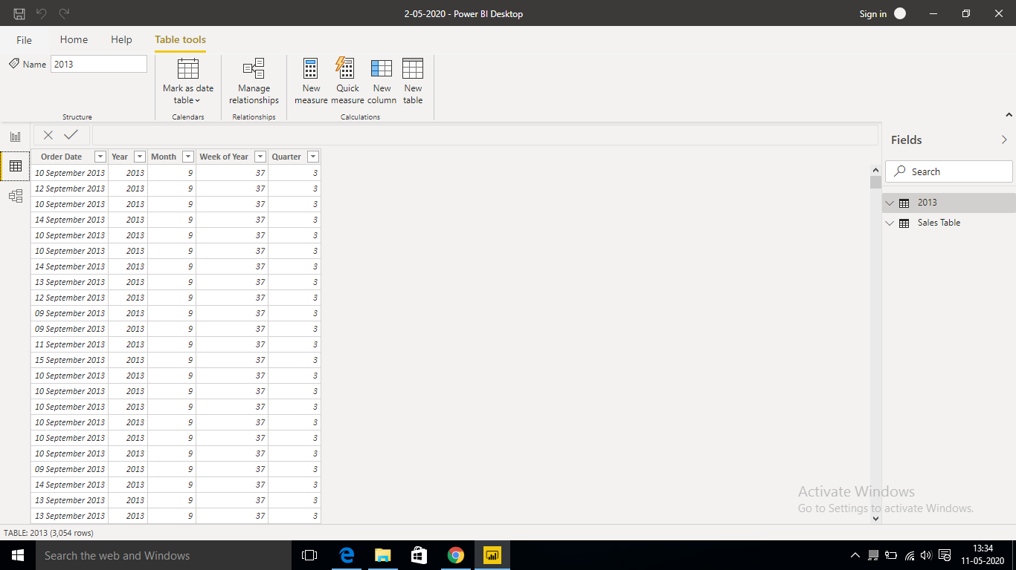

**c) Model View**

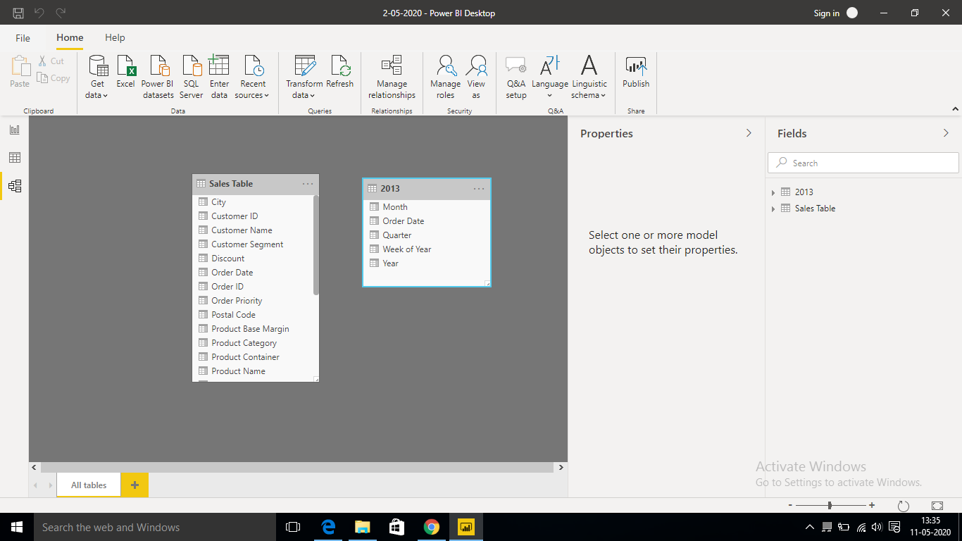

**d) Power Query Editor**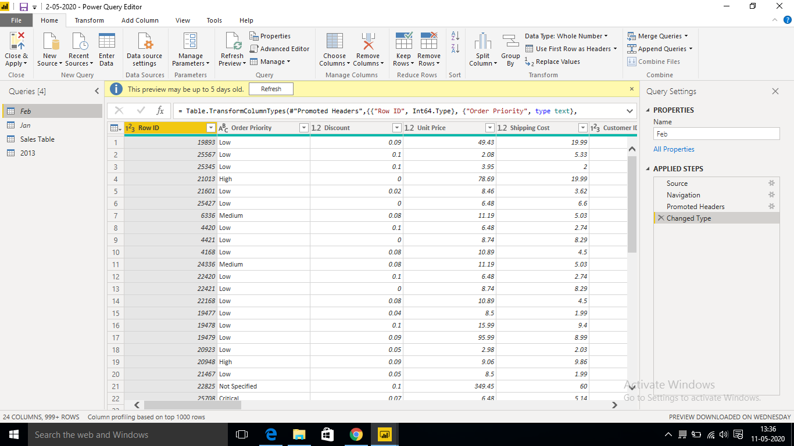

**e) Advance Editor**

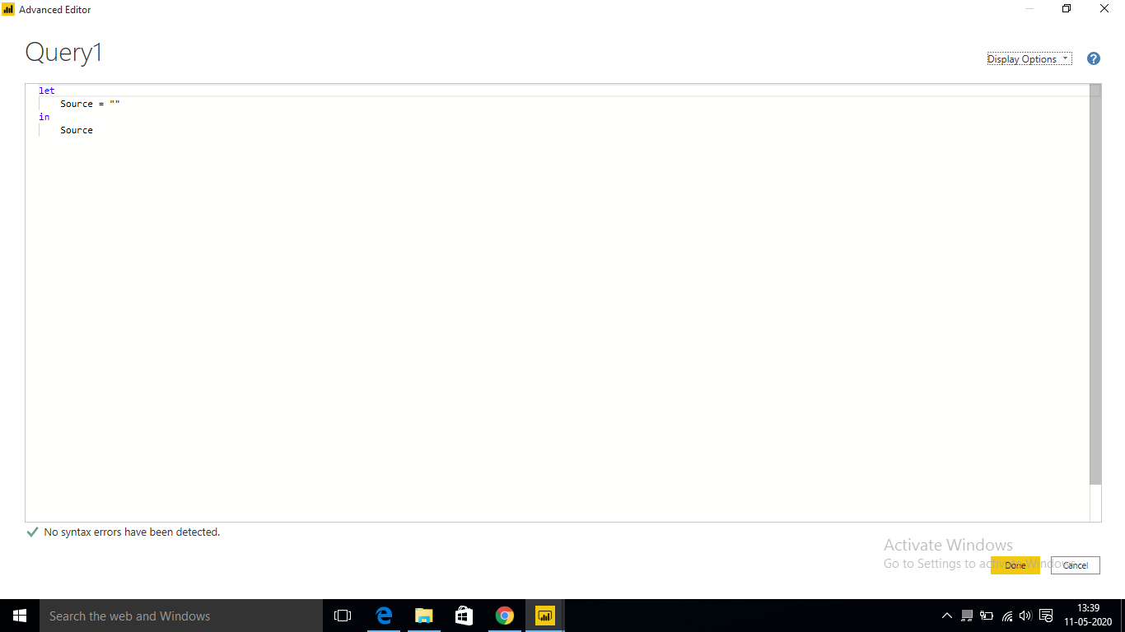

Power BI Tools and their prices.

|  |  |
| --- | --- |
| **Tool** | **Price(USD)** |
| Power BI Desktop | Free |
| Power BI Premium | 4,995  (Monthly price per dedicated cloud compute and storage resource with annual subscription) |
| Power BI Pro | 9.99  (Monthly price per user)  Monthly price per us |